Installing Tanzu Basic

* Bootstrap environment ( I am using WIN 10 ). This is the laptop, Host, or Server that the initial startup of the management cluster
* Pregrequisites
* Installing Kubectl
* <https://kubernetes.io/docs/tasks/tools/install-kubectl/>
* I followed the powershell instructions
* Don’t forget to add the install path to the path env variable for all
* Enable-WindowsOptionalFeature -Online -FeatureName Microsoft-Hyper-V,Containers -All
* Install Docker Desktop
* <https://docs.docker.com/docker-for-windows/install/>
* and it must be running and in linux container mode.
* if you see this when starting docker desktop. It means you need to install this for linux containers to work.
* 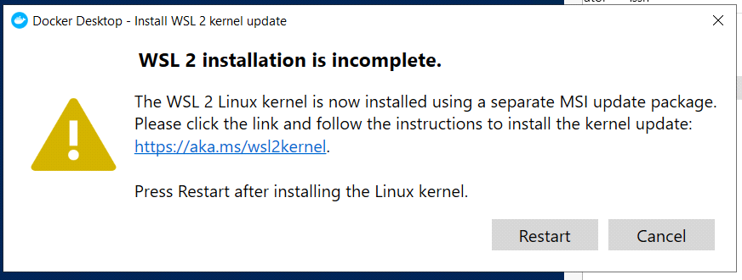
* Switching to linux containers throws this error. Which means you forgot to install virtualization platform. dism.exe /online /enable-feature /featurename:VirtualMachinePlatform /all /norestart
* 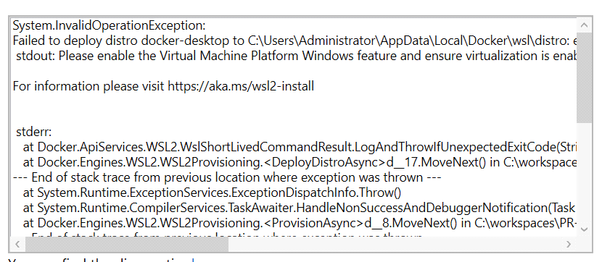
* Install TKG CLI
  + - https://docs.vmware.com/en/VMware-Tanzu-Kubernetes-Grid/1.2/vmware-tanzu-kubernetes-grid-12/GUID-install-tkg.html
    - Download CLI and matching Kubctl for your environment (windows)
    - Unzip --- tar -xzvf S:\VMware\Tanzu\tkg-windows-amd64-v1.2.1-vmware.1.tar.gz -C S:\VMware\Tanzu
    - Unzip – kubctl with gzip
    - Rename tkg windows to c:\program files\TKG\tkg.exe
    - Add to path
    - Rename kubctl… to Kubctl and copy to C:\Kube. Overwrite the version that is there.
* Deploy management cluster
* <https://docs.vmware.com/en/VMware-Tanzu-Kubernetes-Grid/1.2/vmware-tanzu-kubernetes-grid-12/GUID-mgmt-clusters-vsphere.html>
* Optional Resource pool ( I am not using one)
* Folder for Tanzu VMs ( Tanzu )
* vSphere SSO account for Tanzu
* SSH Keygen
* - Note: ssh-agent needs to be running but it is disabled. Set service to manual and start service then these commands will work.
* - Get-Service ssh-agent | select startup type
* - to verify service is disabled
* - then Get-Service ssh-agent | set-service -starttype manual
* - start-service ssh-agent
* - <https://stackoverflow.com/questions/18683092/how-to-run-ssh-add-on-windows>
* - install templates
* - install TKG with UI (recommended first time)
* - <https://docs.vmware.com/en/VMware-Tanzu-Kubernetes-Grid/1.2/vmware-tanzu-kubernetes-grid-12/GUID-mgmt-clusters-vsphere-ui.html>
* - TKG init –ui
* - ~~Note : when I first ran this I had problems with docker not being in the path. This turns out to was because docker desktop was not running. I also had to run with Windows containers. This may have been because I was missing something installed.~~
* - follow the above doc
* - command line is created as an example
* -tkg init -i vsphere --vsphere-controlplane-endpoint aaa.bbb.ccc.ddd -p prod --ceip-participation false --name kw-tkgmanagment --cni antrea -v 6

Error: [1222 18:07:03.73120]: init.go:78] unable to set up management cluster, : unable to create bootstrap cluster: failed to create kind cluster tkg-kind-bvh7nv3sr0vh3o5rtut0: failed to pull image "registry.tkg.vmware.run/kind/node:v1.19.3_vmware.1": command "docker pull registry.tkg.vmware.run/kind/node:v1.19.3_vmware.1" failed with error: exit status 1